**EZEKIEL ISAAC NARAYANASAMI**

**ST10359128**

**CLDV6212**

**POE: PART 2 & 1**

**WEBSITE URL:** <https://st10359128-fsgedcfmapcfbveu.southafricanorth-01.azurewebsites.net>

**GITHUB LINK:** <https://github.com/VCDN-2025/cldv6212-poe-part-2-ST10359128.git>

**PART 2**

1. **STORE INFORMATION INTO AZURE TABLES:**

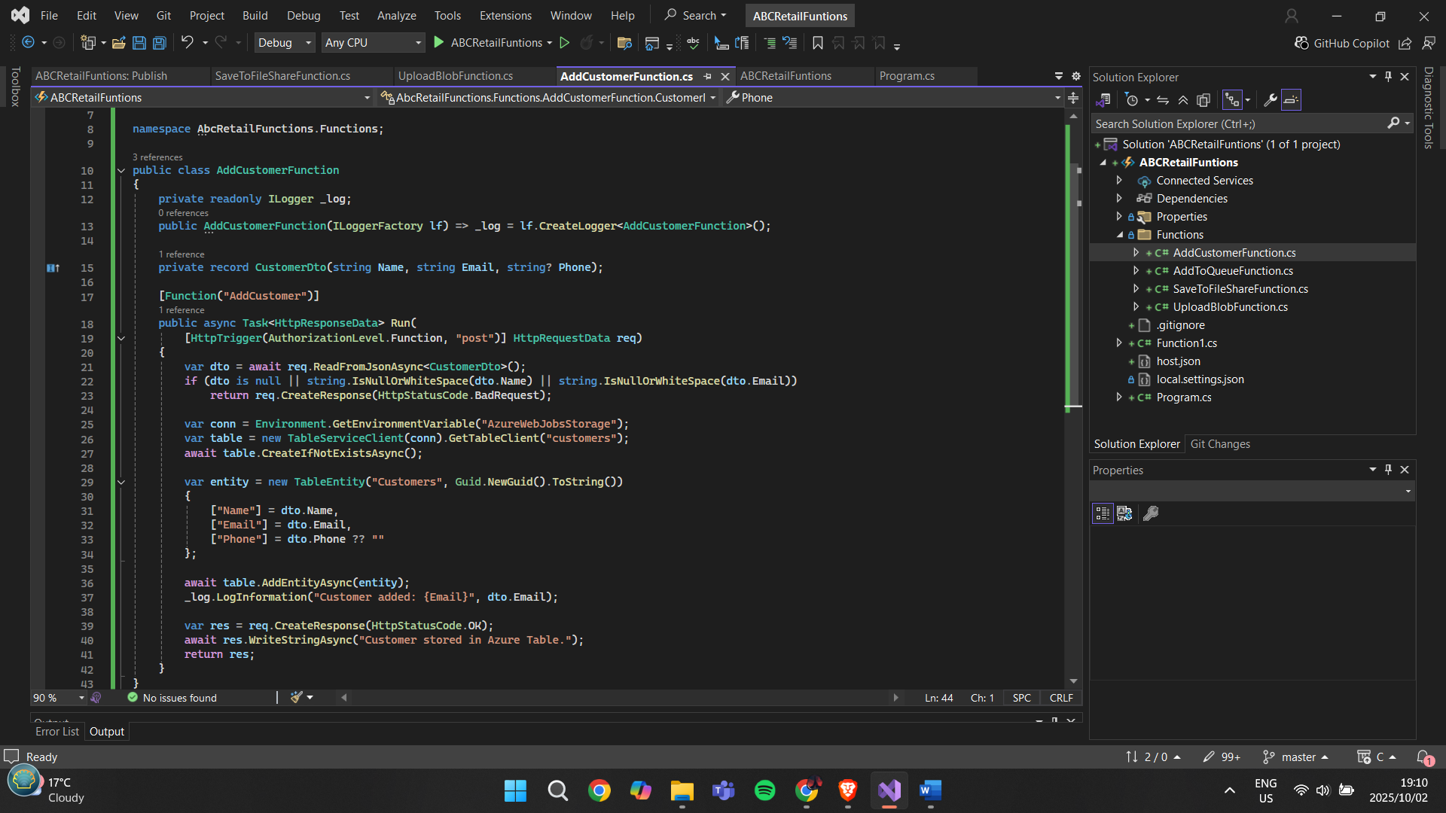

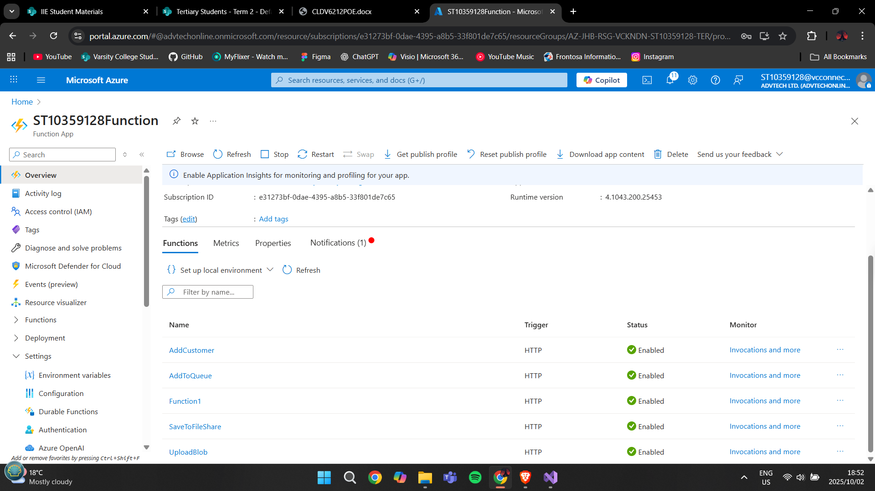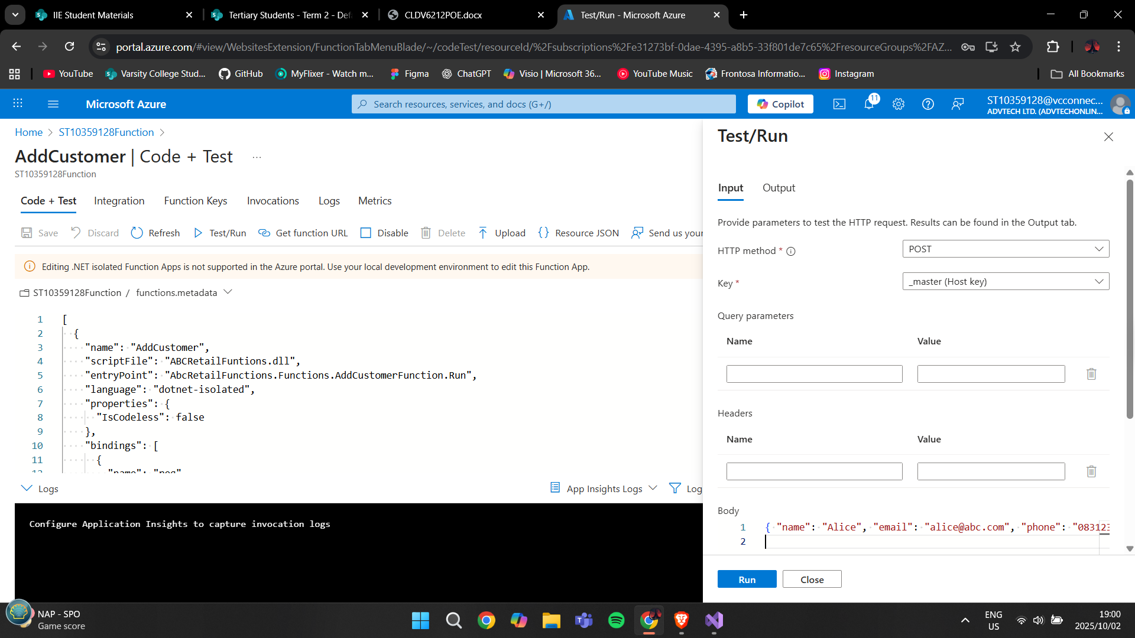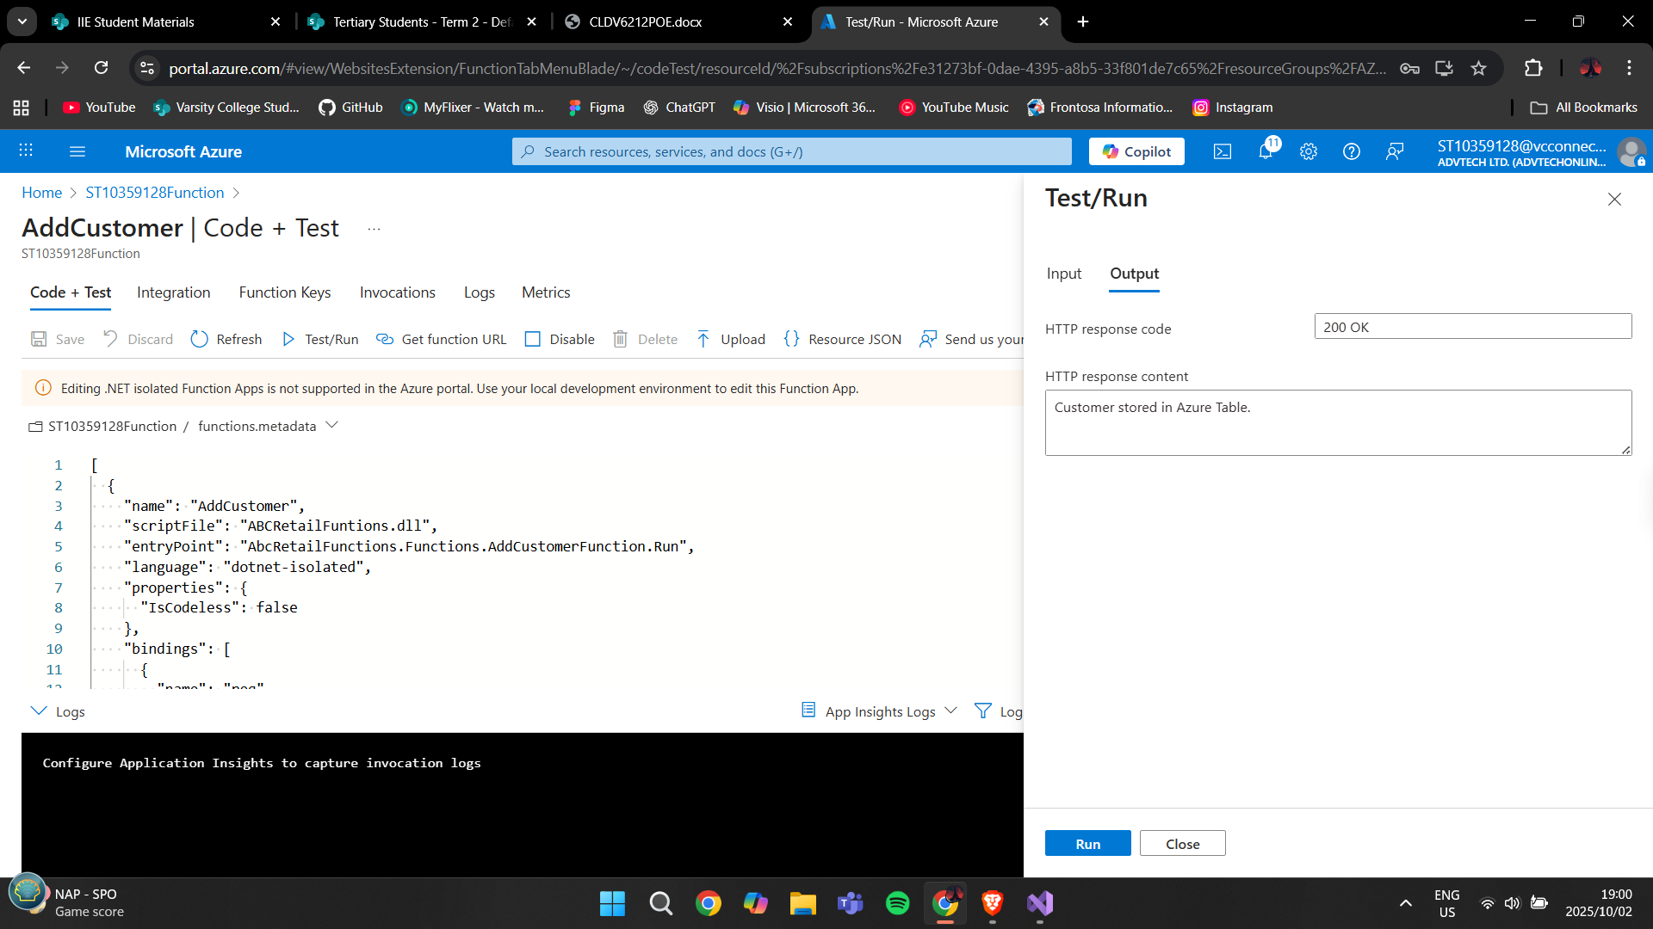

**WRITE TO BLOB STORAGE:**

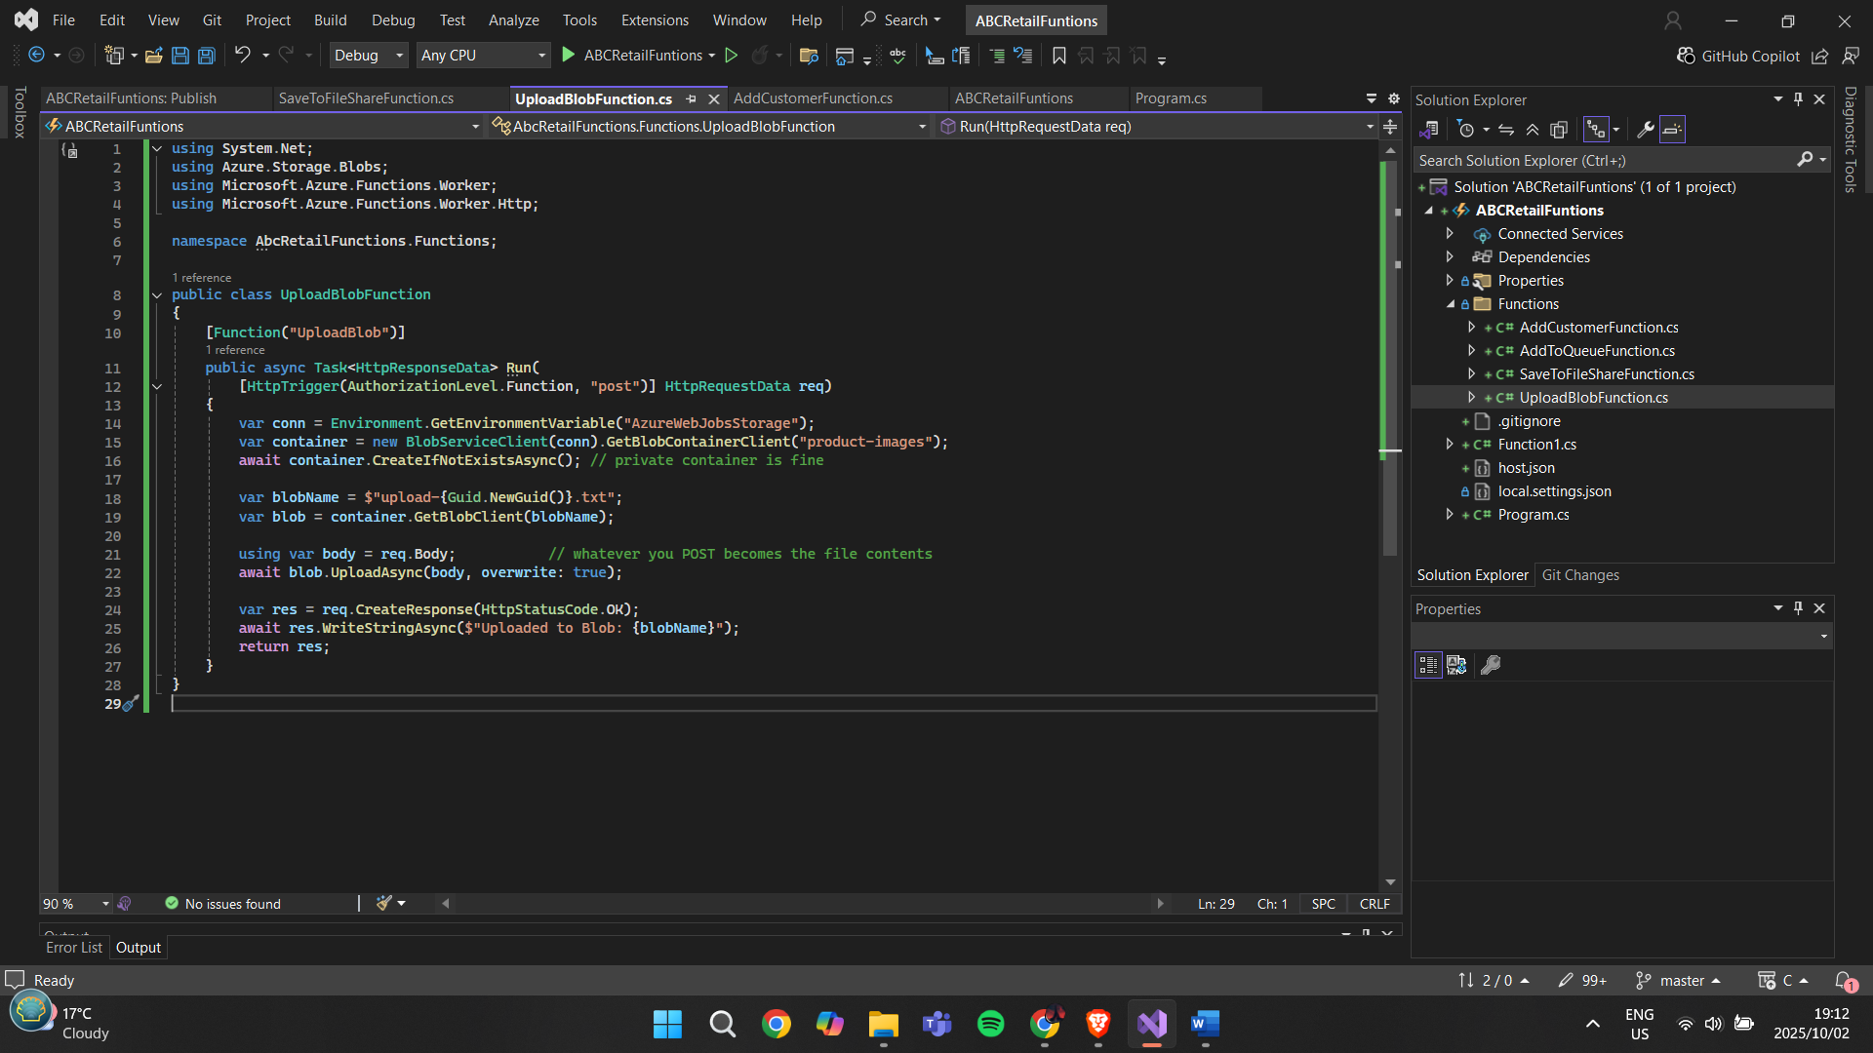



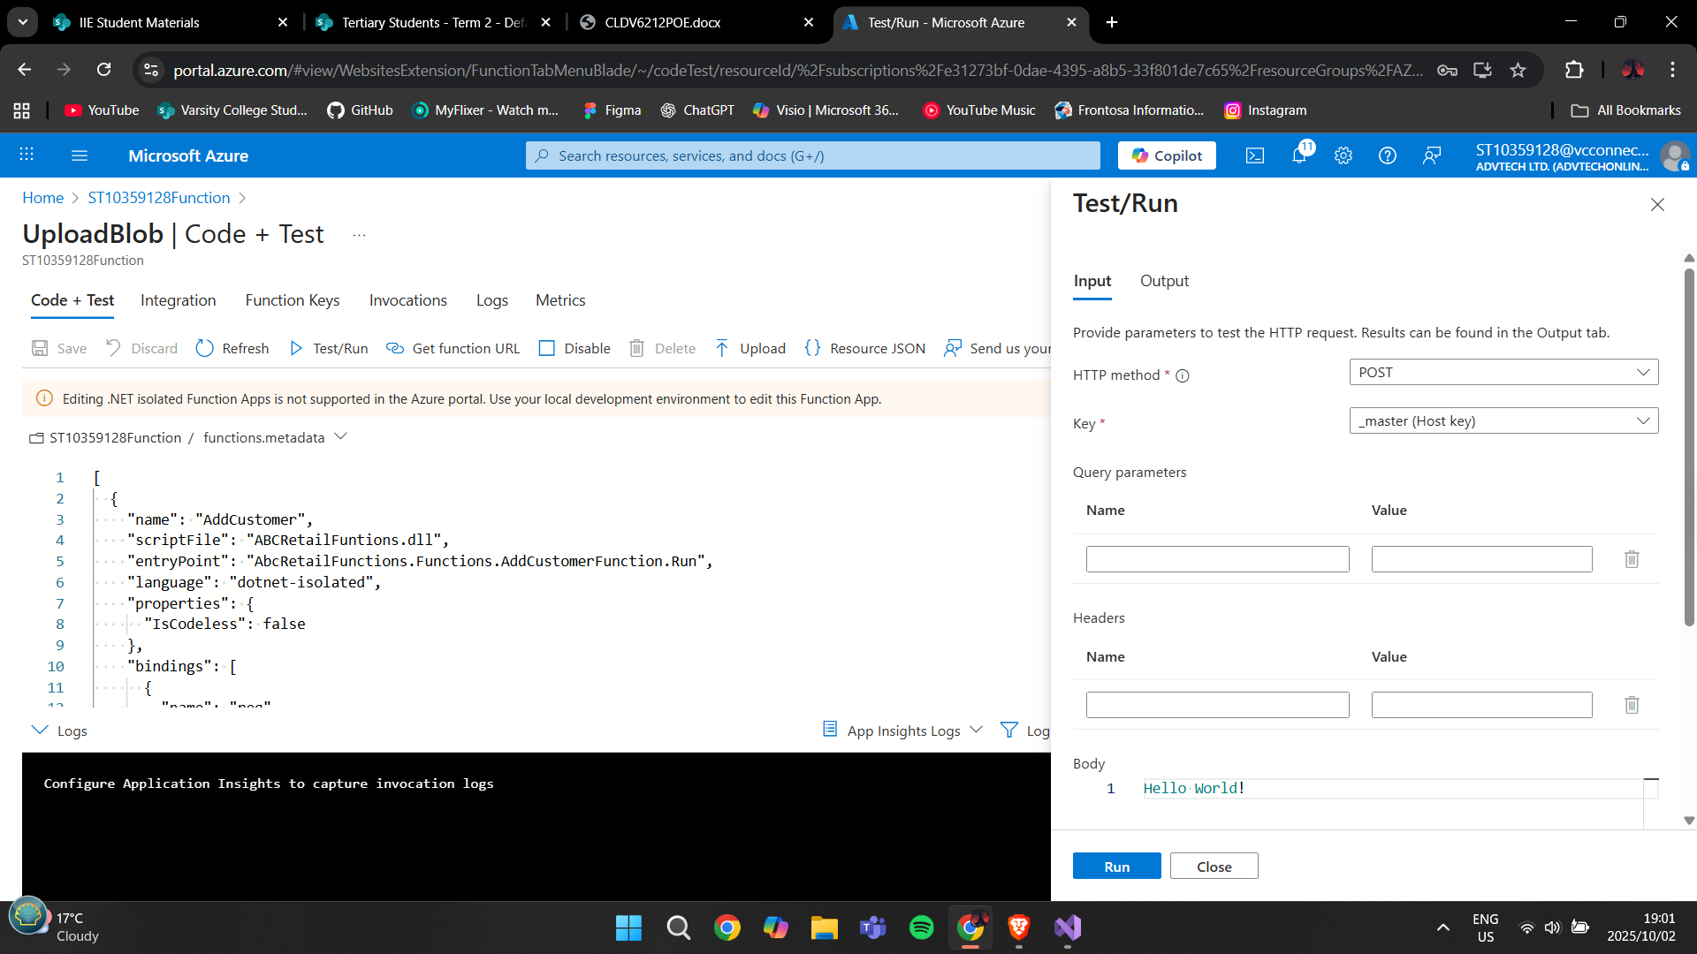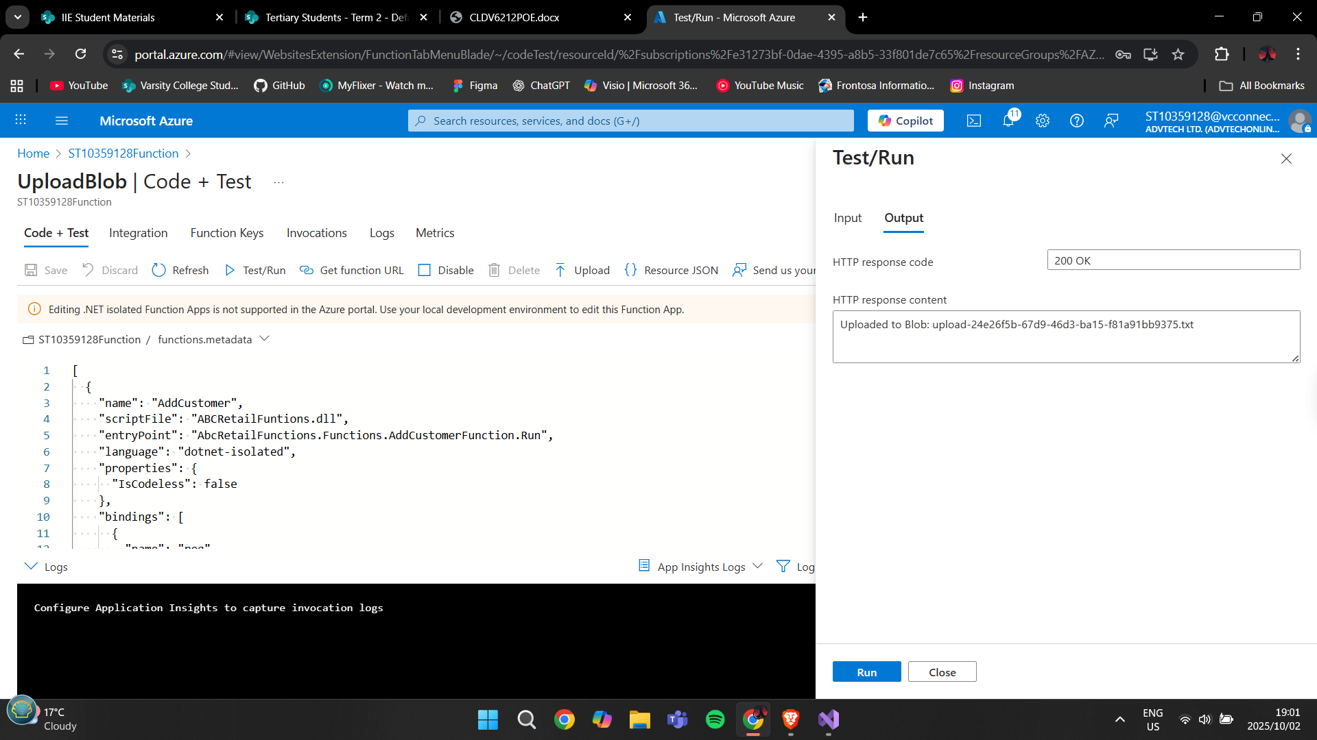

**QUEUES:**

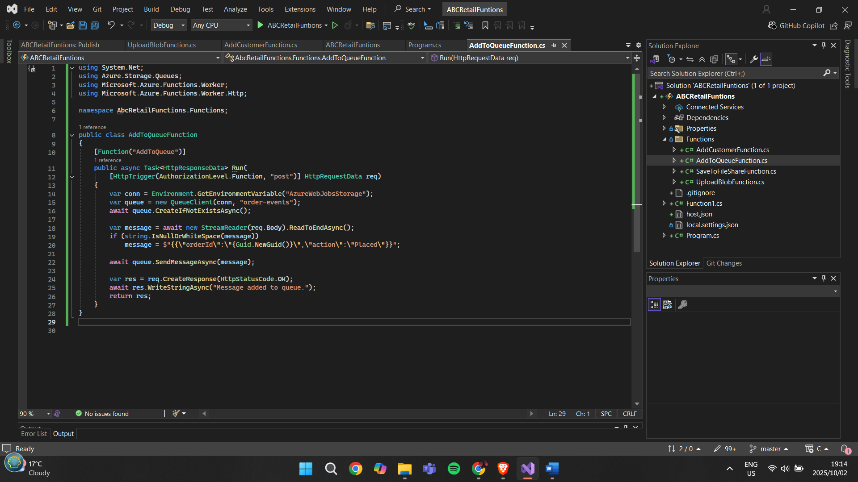



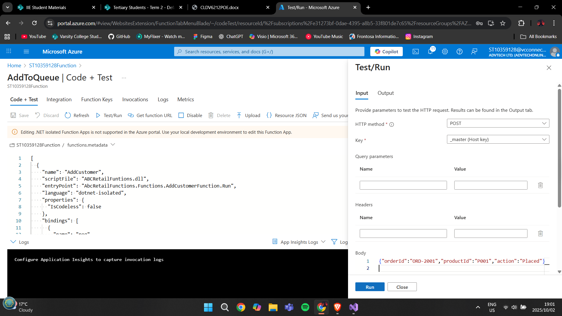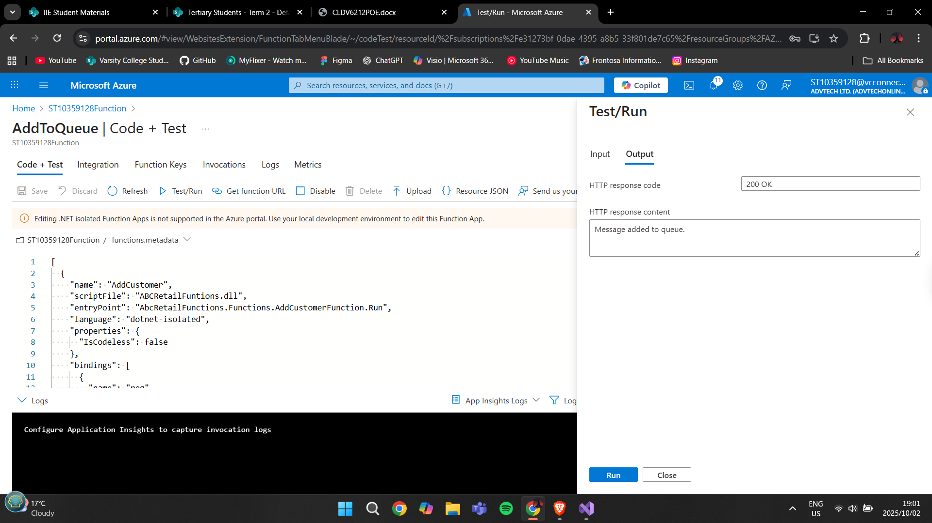

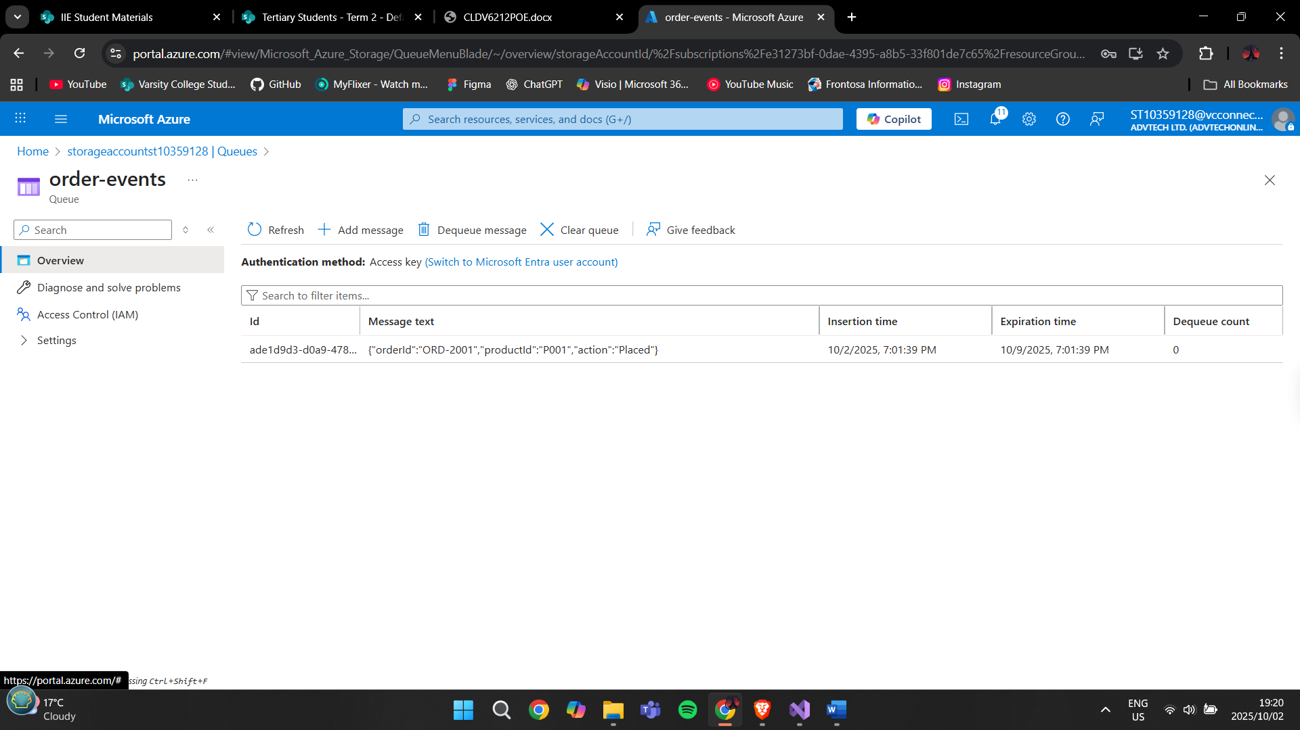

**AZURE FILES:**

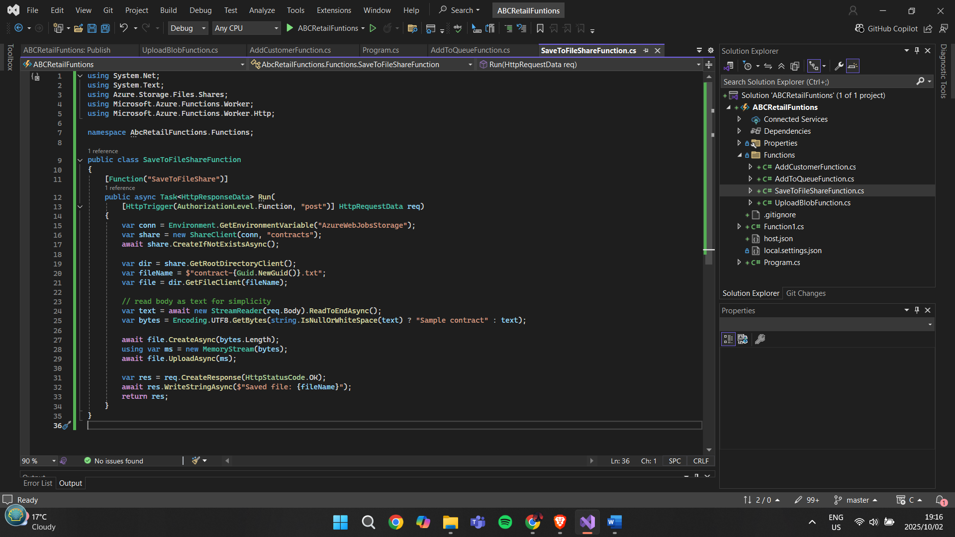



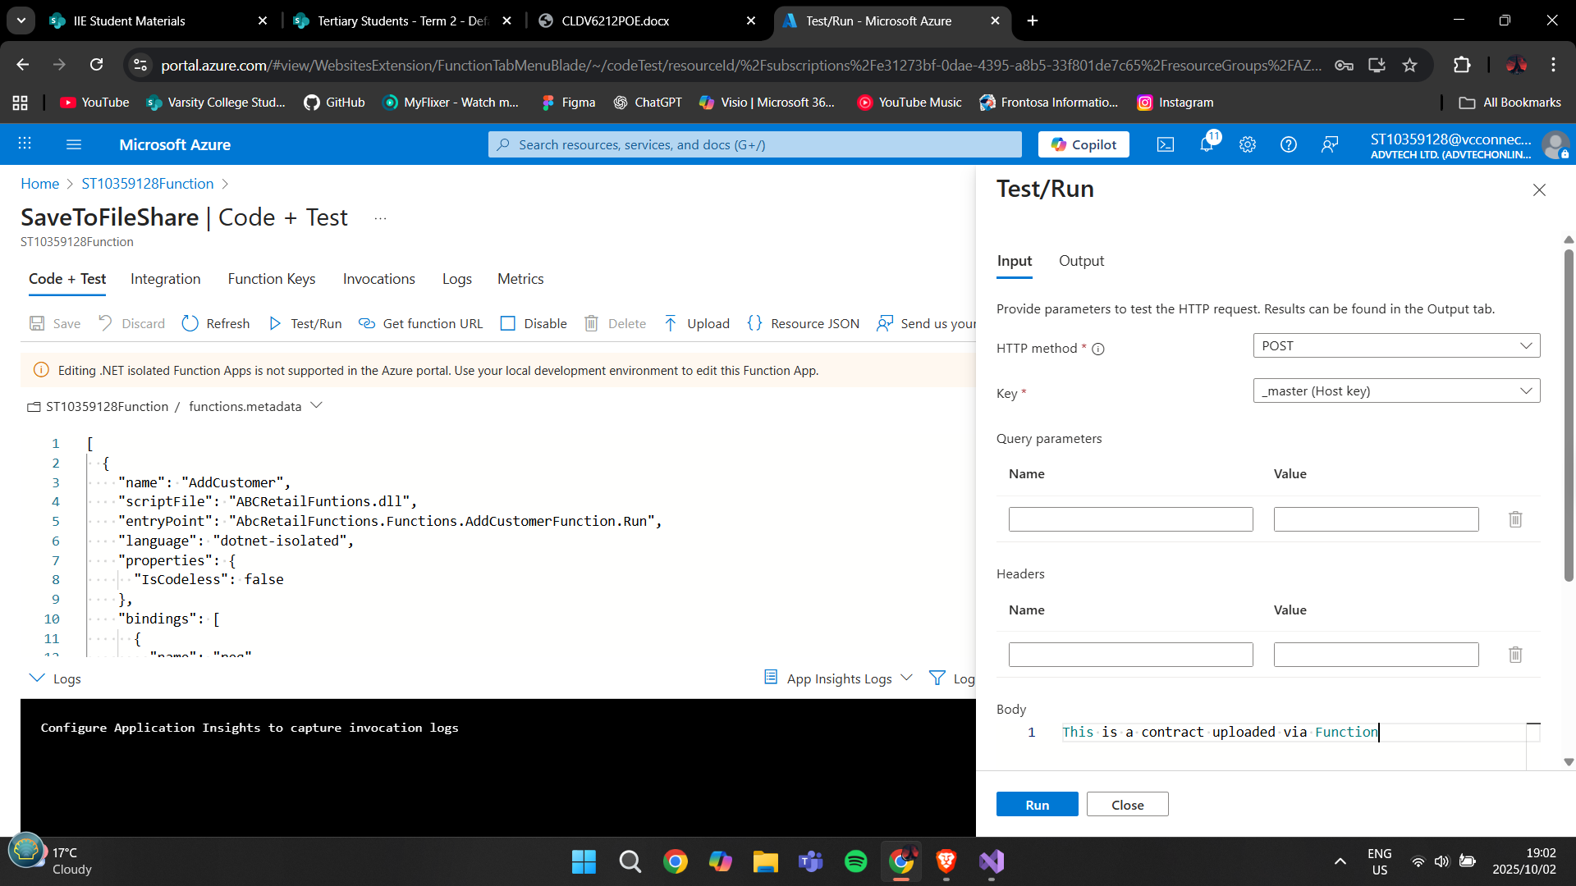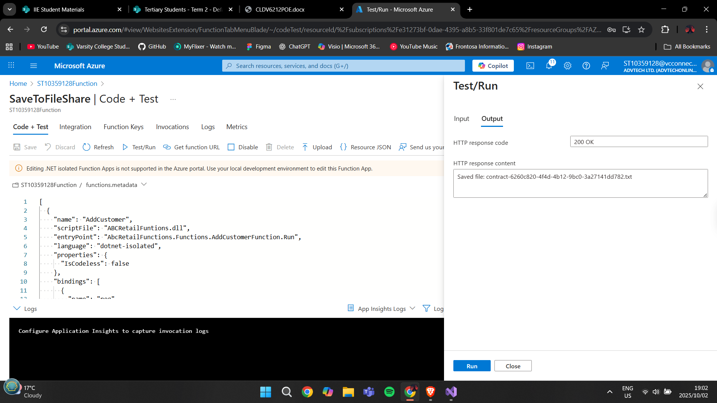

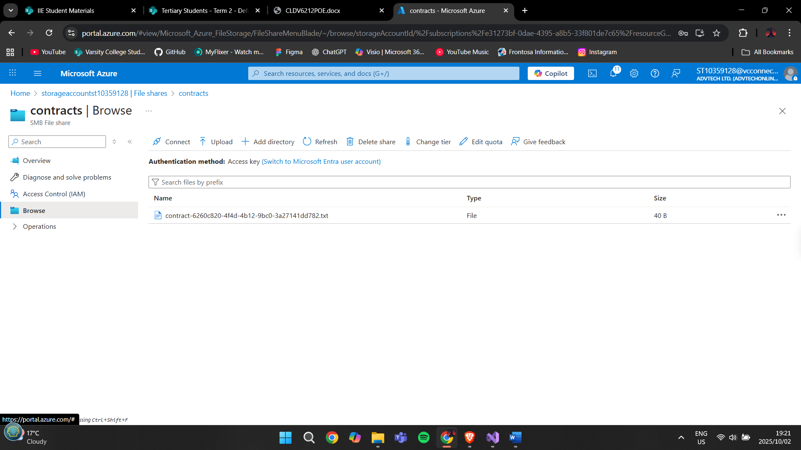

**B.**

**AZURE EVENT HUBS:**

Azure Event Hubs is basically a service that can take in a huge amount of data in real-time. It’s designed to collect events like customer clicks, searches, or transactions the moment they happen. In our case, every time a customer browses products, adds items to the cart, or places an order, an event is sent into the Event Hub. The system can then immediately process these events and update things like stock availability or order confirmations(Microsoft, 2024).

Why this helps the customer:

They get real-time updates, for example, if a product goes out of stock while they are shopping, they’ll see it instantly.

It makes the app feel fast and responsive, with no delays in showing the latest info(Wyllie, 2023).

It can also improve customer support, because if there’s strange activity the system can alert staff right away to assist.

**AZURE EVENT BUS:**

Azure Service Bus is more about making sure that messages between different parts of the system don’t get lost. It uses queues to handle requests, so even if one part of the system is busy or temporarily offline, the customer’s action is still safely stored and processed later. For example, if a customer places an order, the front-end app will send that request to the Service Bus. The Service Bus then passes it on to the right back-end services like stock checking, payments, or shipping(Microsoft, 2024).

Why this helps the customer:

Their orders or requests are always reliable and won’t get lost, even if there’s a technical issue in the background(Dehghani, 2022).

It improves the overall experience because customers don’t have to wait for every system to finish working in real time, the order goes into the queue and is processed in the right order.

This makes the whole system more scalable and efficient, meaning it can handle lots of customers at once without slowing down.

**References for part 2:**

Dehghani, Z. (2022). Software Architecture: The Hard Parts. Sebastopol: O’Reilly Media.

Microsoft. (2024a). What is Azure Event Hubs? Microsoft Docs. Available at: <https://learn.microsoft.com/en-us/azure/event-hubs/event-hubs-about>

Microsoft. (2024b). What is Azure Service Bus? Microsoft Docs. Available at: <https://learn.microsoft.com/en-us/azure/service-bus-messaging/service-bus-messaging-overview>

Microsoft. (2024c). Azure Functions Overview. Microsoft Docs. Available at: <https://learn.microsoft.com/en-us/azure/azure-functions/functions-overview>

Microsoft. (2024d). Introduction to Azure Storage. Microsoft Docs. Available at: <https://learn.microsoft.com/en-us/azure/storage/common/storage-introduction>

Microsoft. (2024e). Azure Queue Storage Overview. Microsoft Docs. Available at: <https://learn.microsoft.com/en-us/azure/storage/queues/storage-queues-introduction>

Microsoft. (2024f). Azure Blob Storage Overview. Microsoft Docs. Available at: <https://learn.microsoft.com/en-us/azure/storage/blobs/storage-blobs-overview>

Microsoft. (2024g). Azure Table Storage Overview. Microsoft Docs. Available at: <https://learn.microsoft.com/en-us/azure/storage/tables/table-storage-overview>

Wyllie, G. (2023). Architecting Cloud Native Applications. Birmingham: Packt Publishing.

**PART 1**

**WEBSITE PORTAL PAGE**

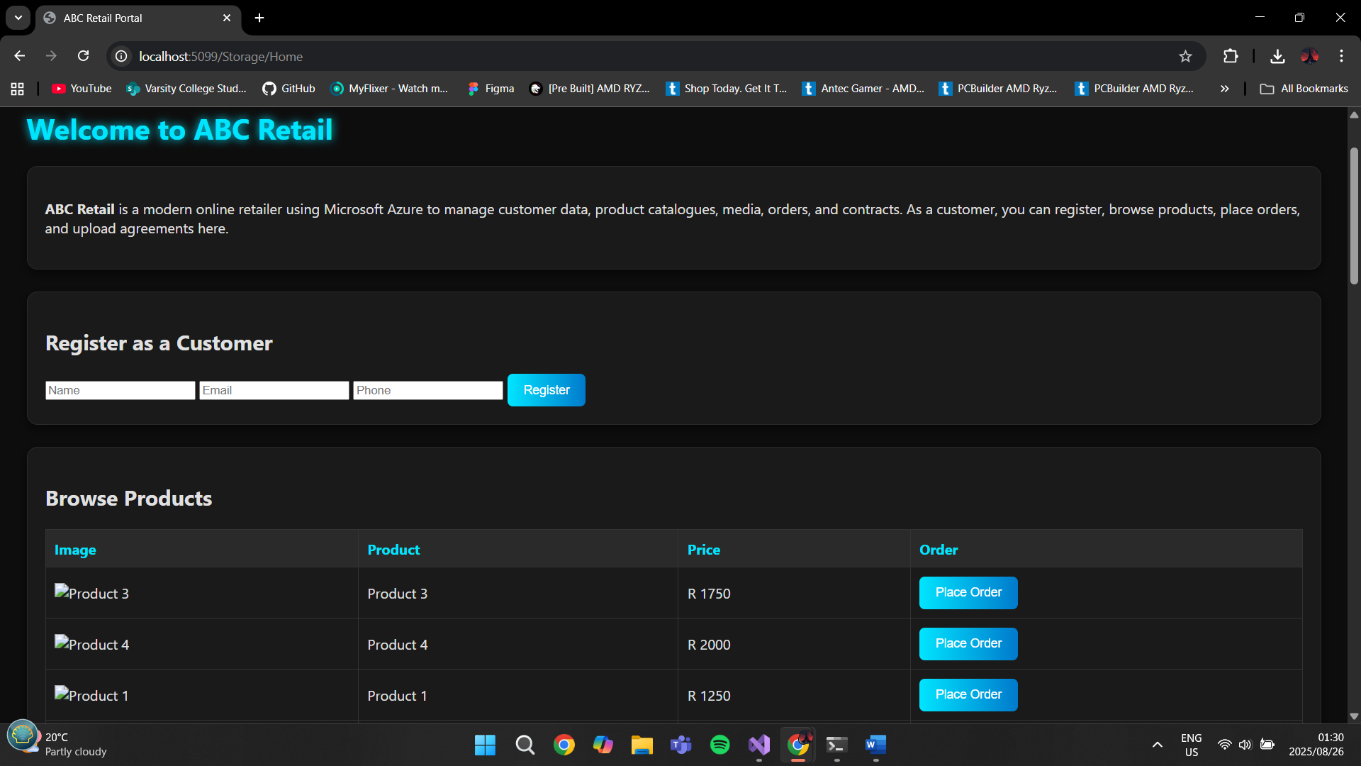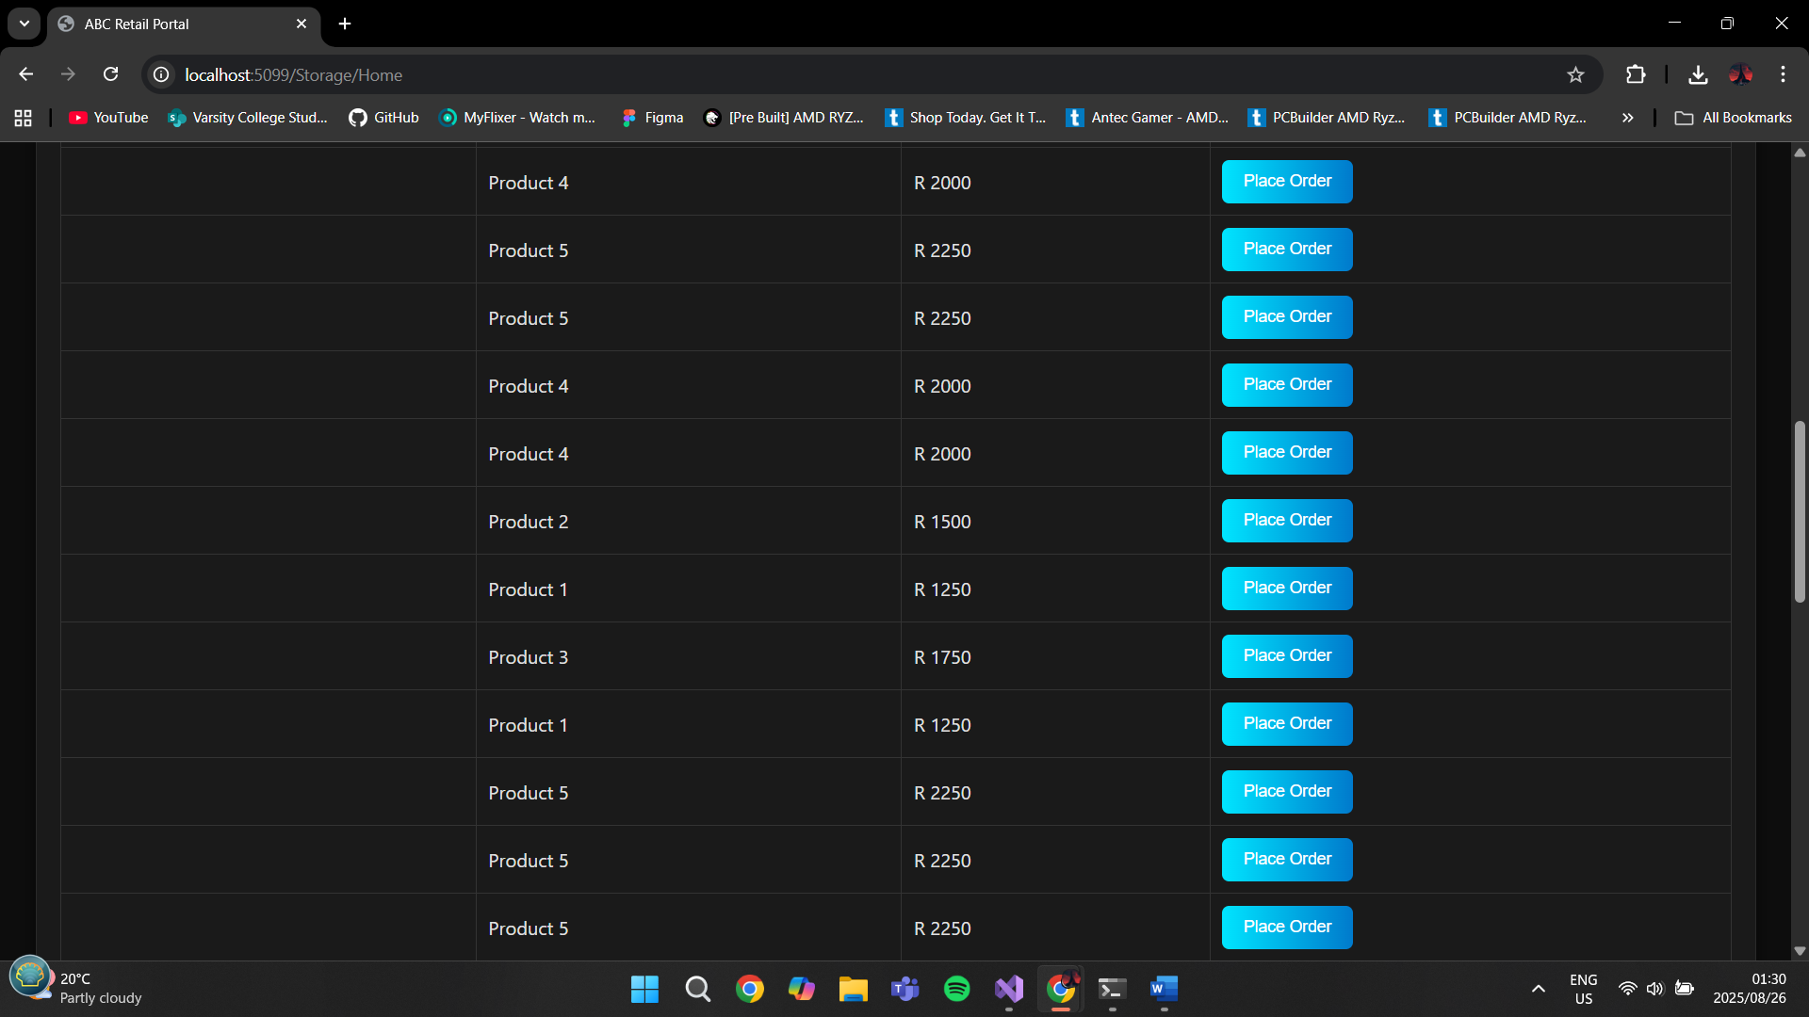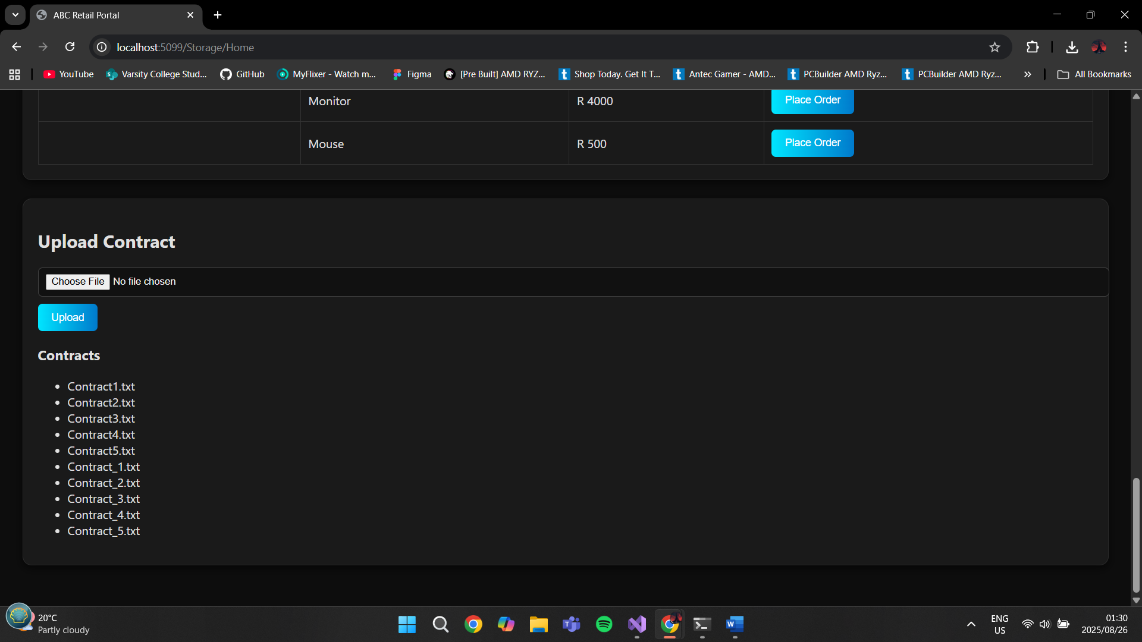

**AZURE TABLES**

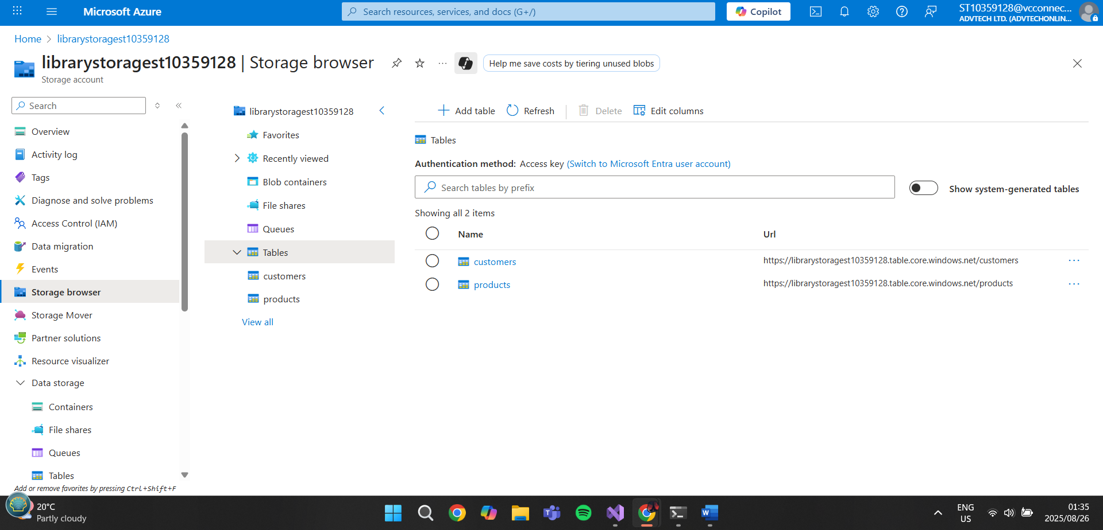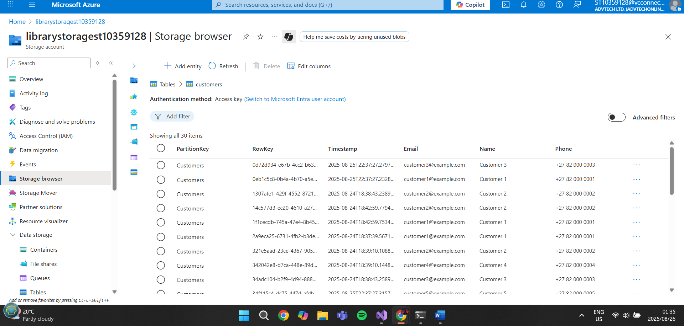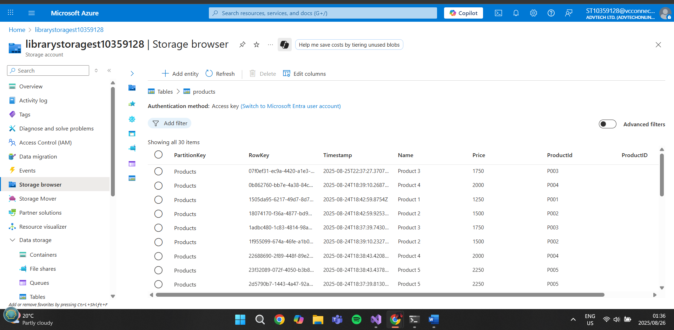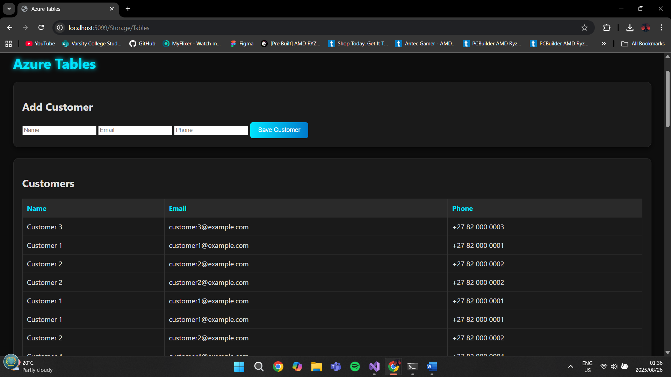

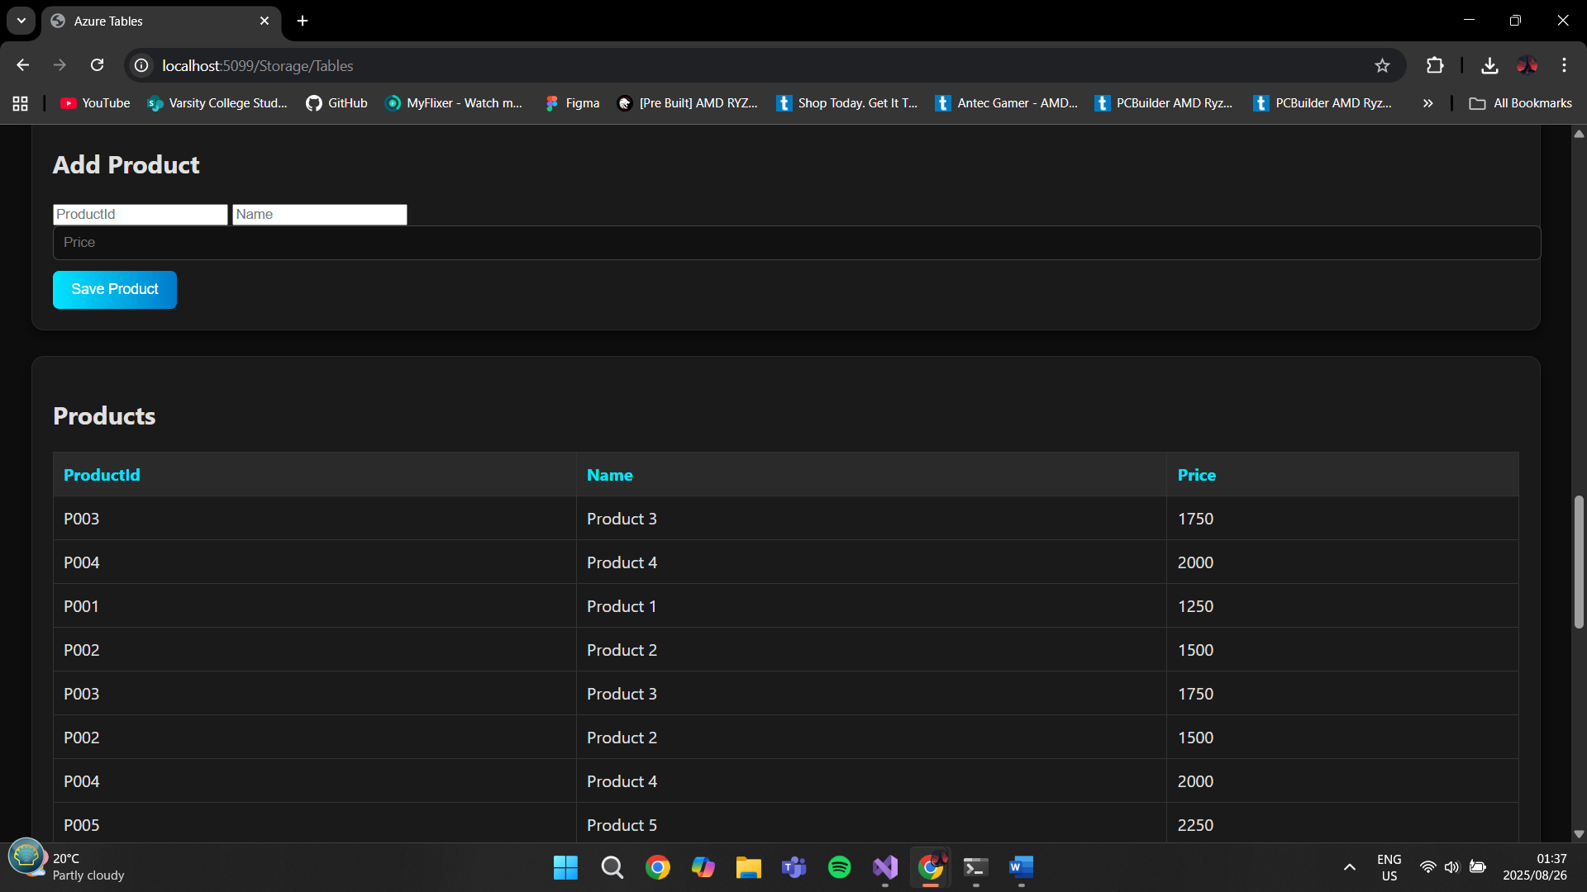

**AZURE BLOB STORAGE**

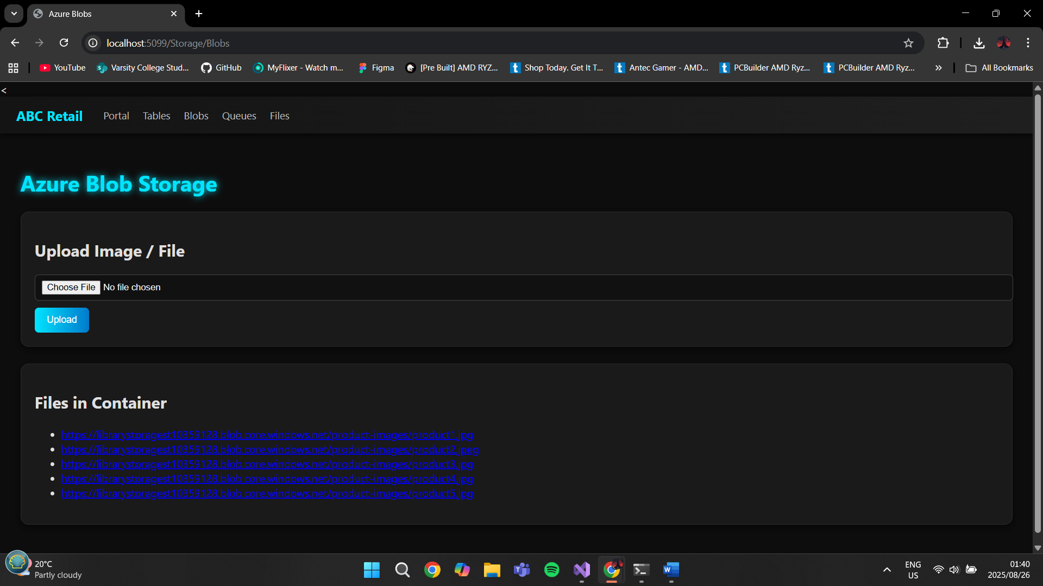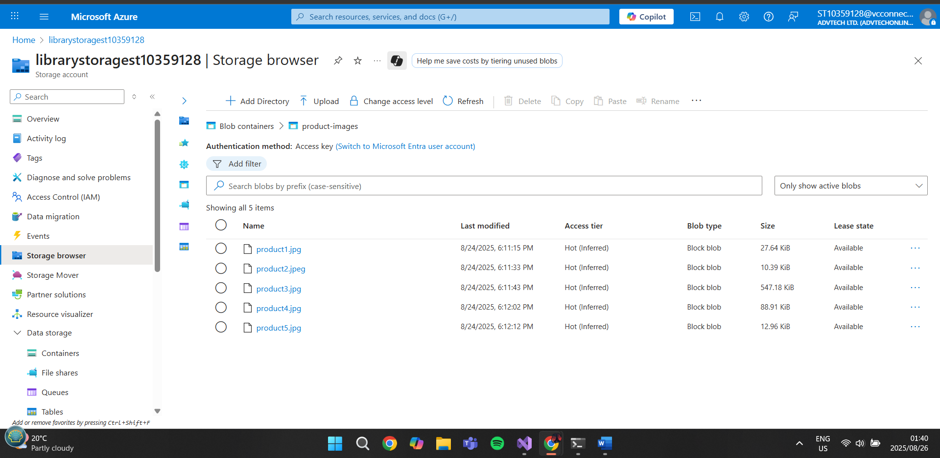

**AZURE QUEUE STORAGE**

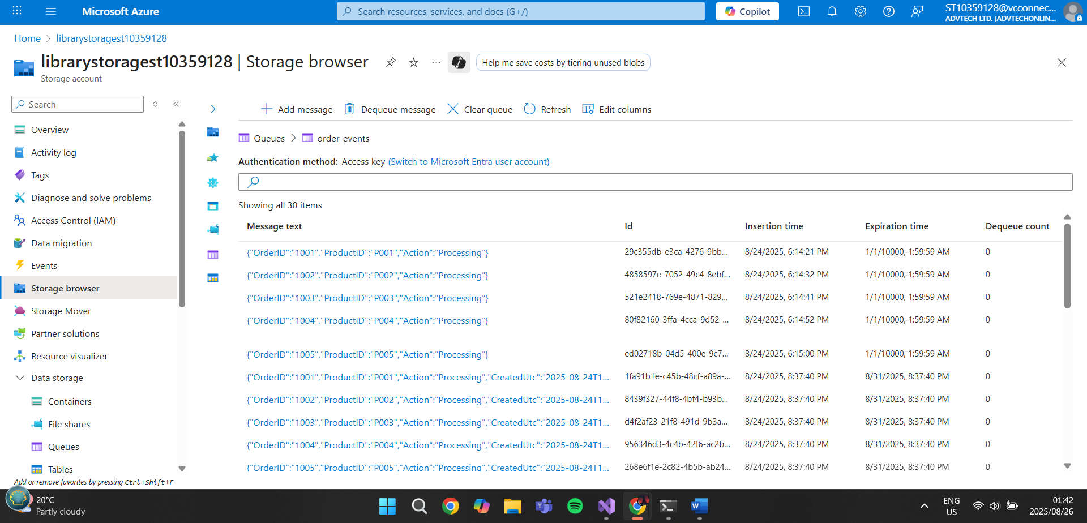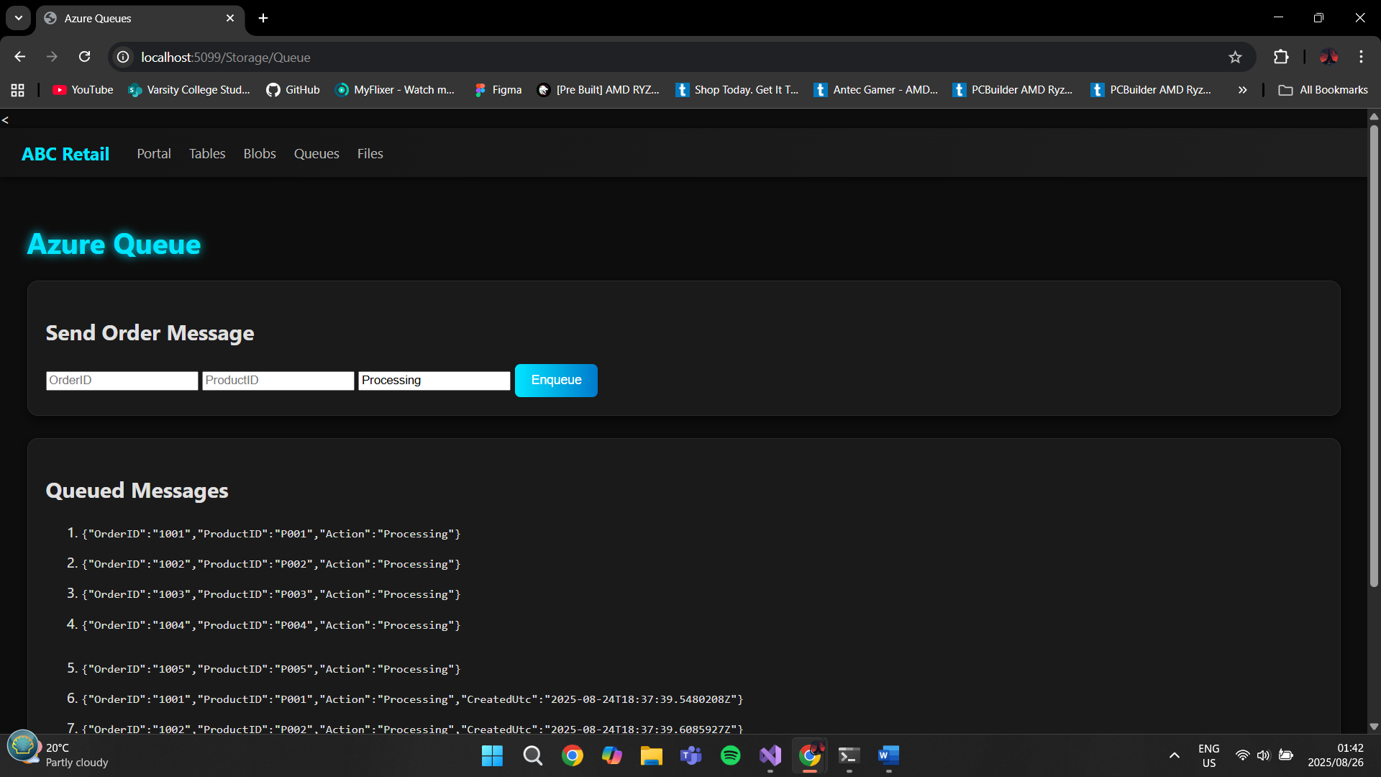

**AZURE FILE STORAGE**

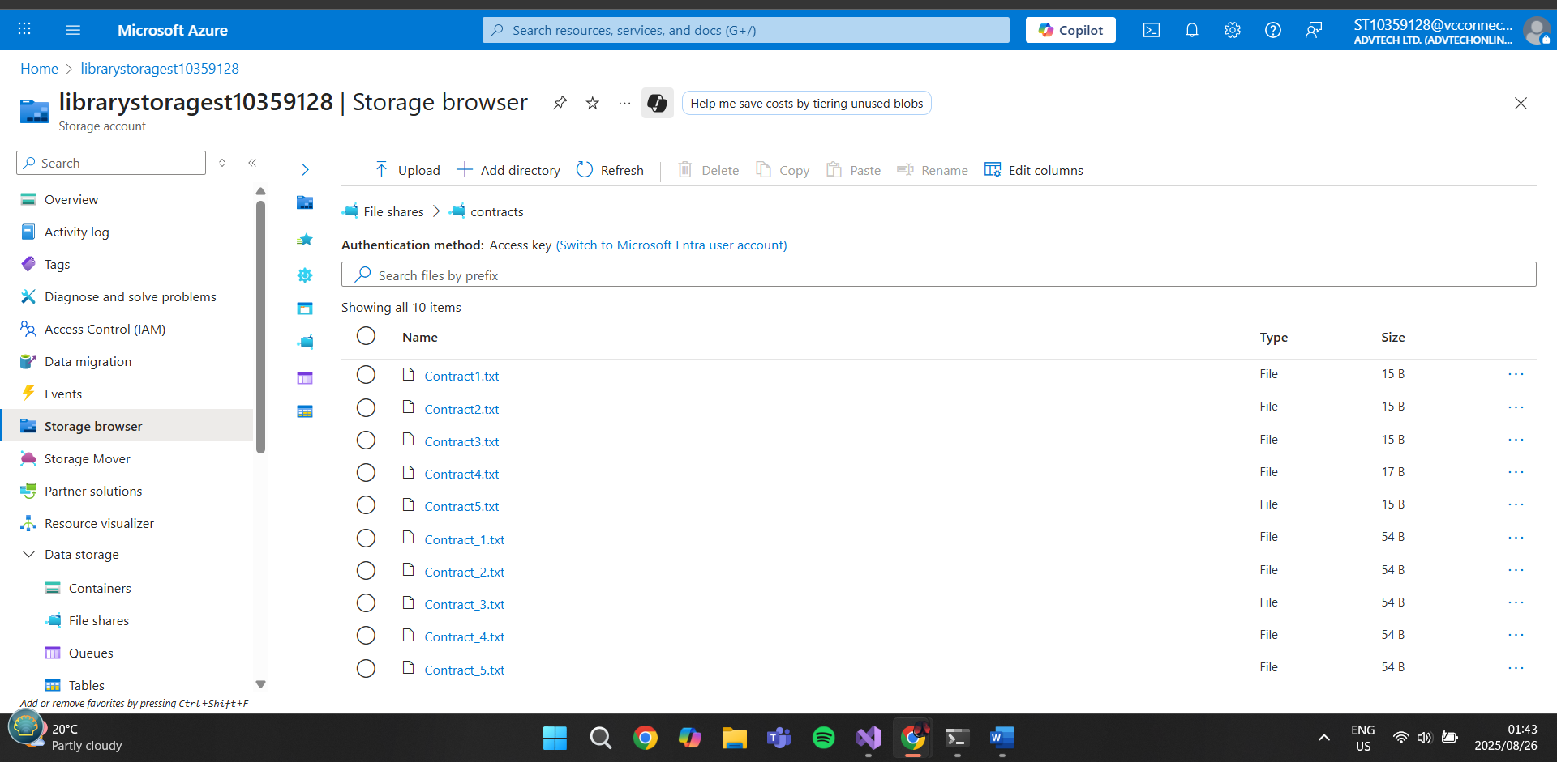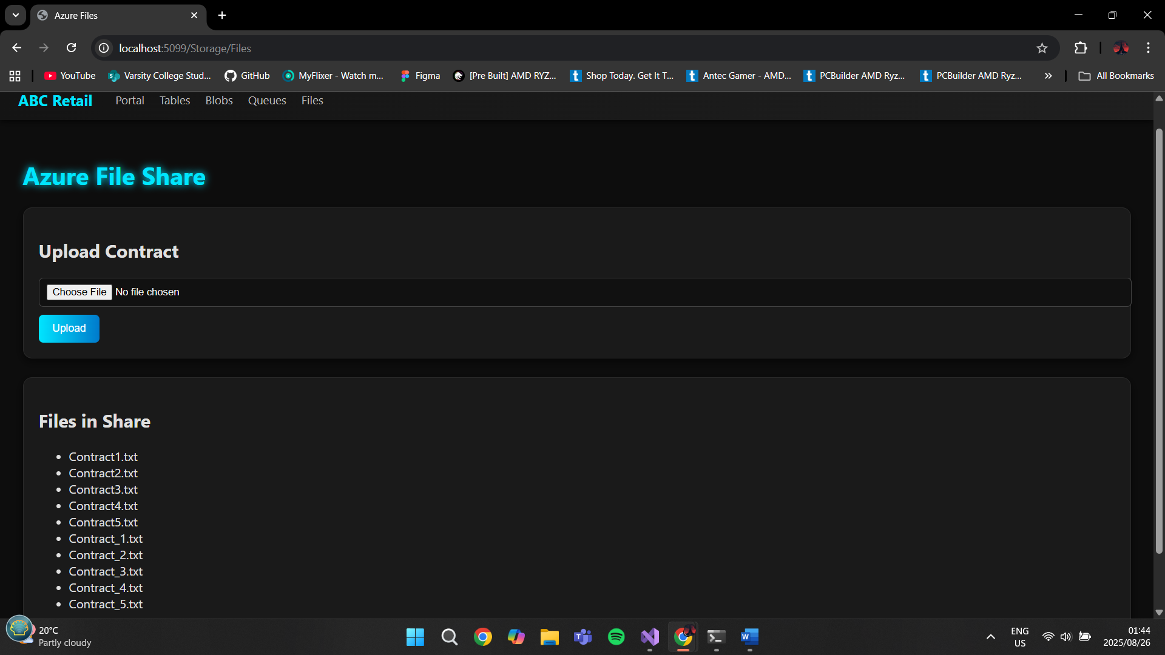

**WEB DEPLOYMENT**

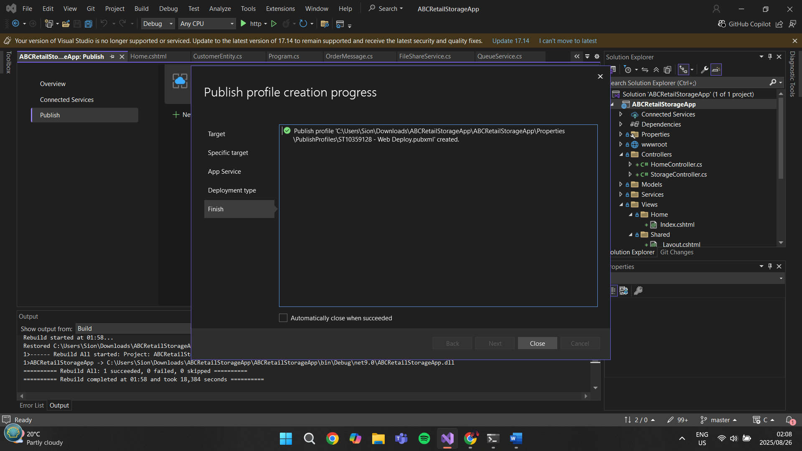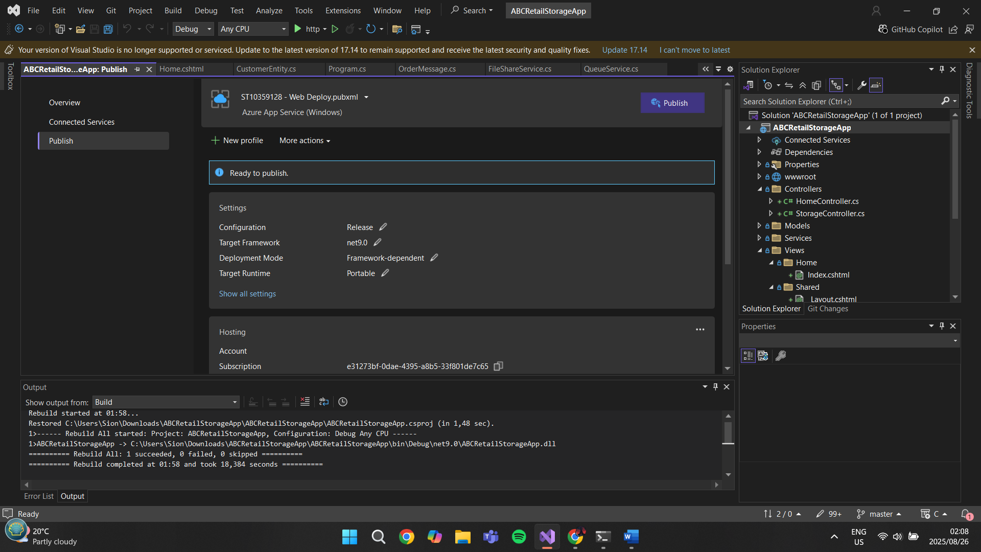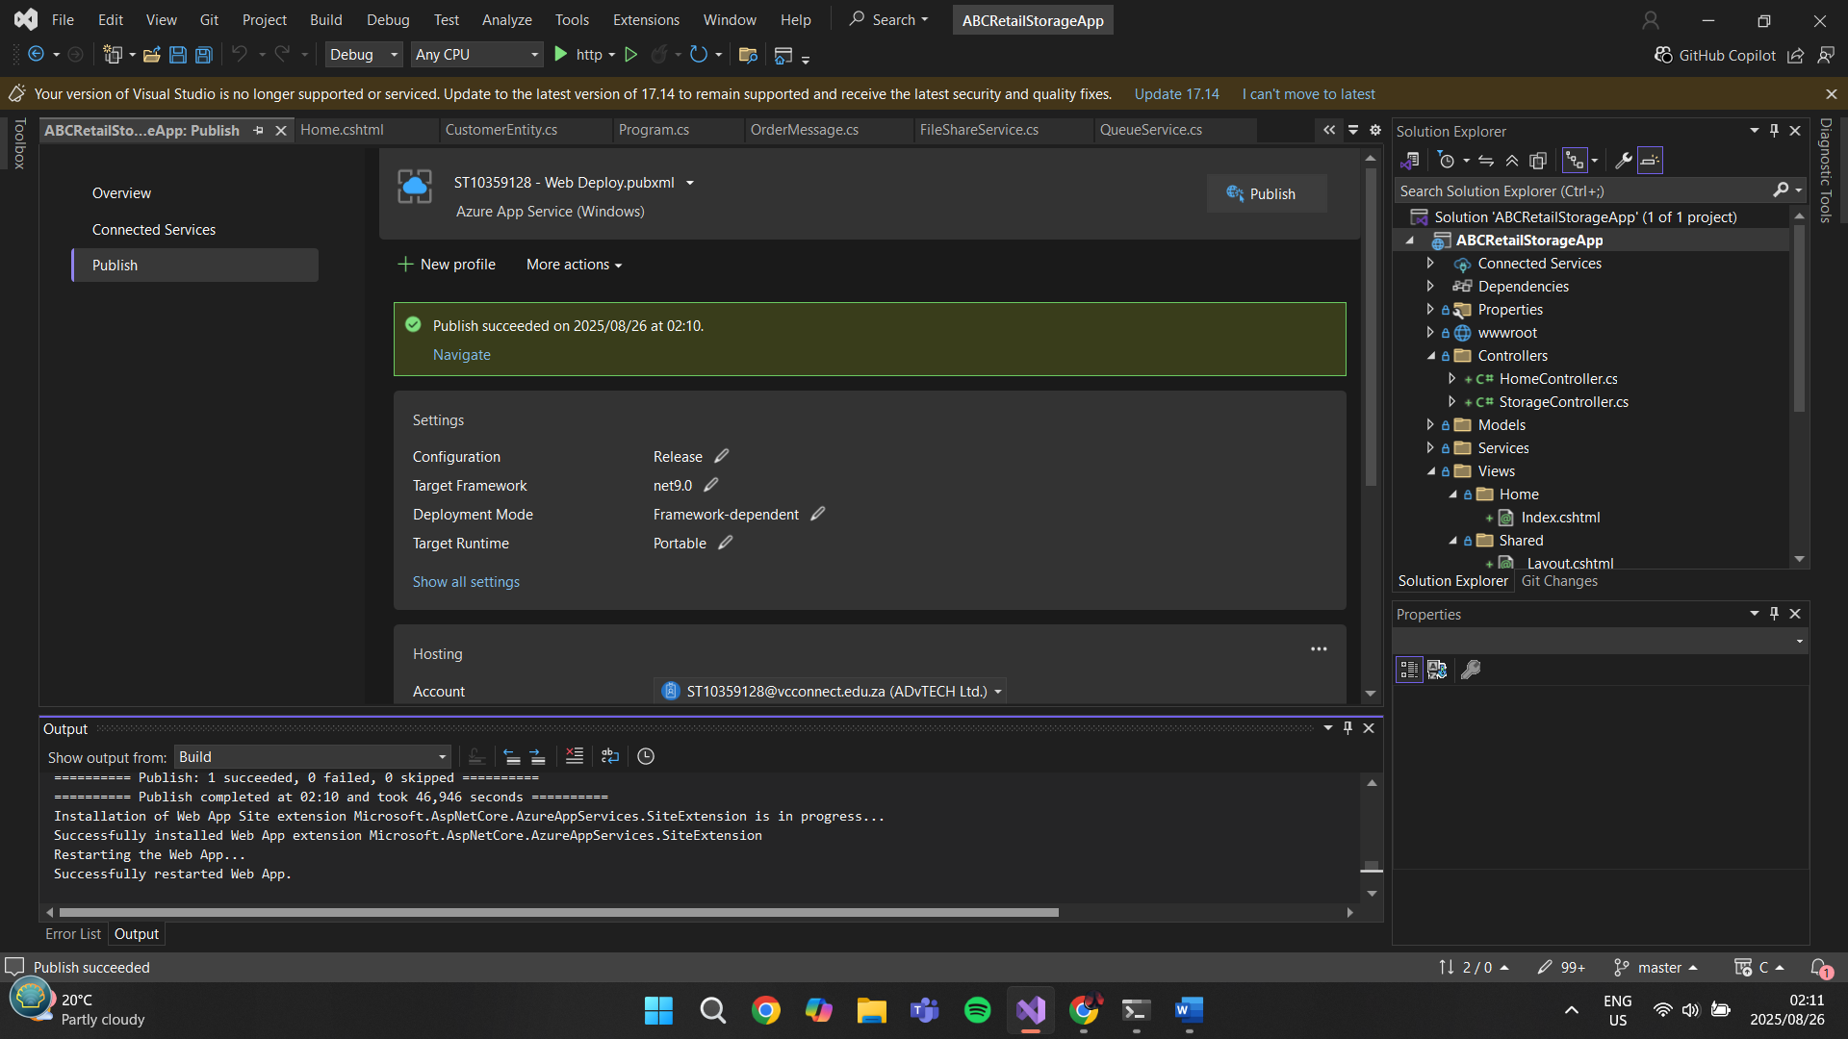

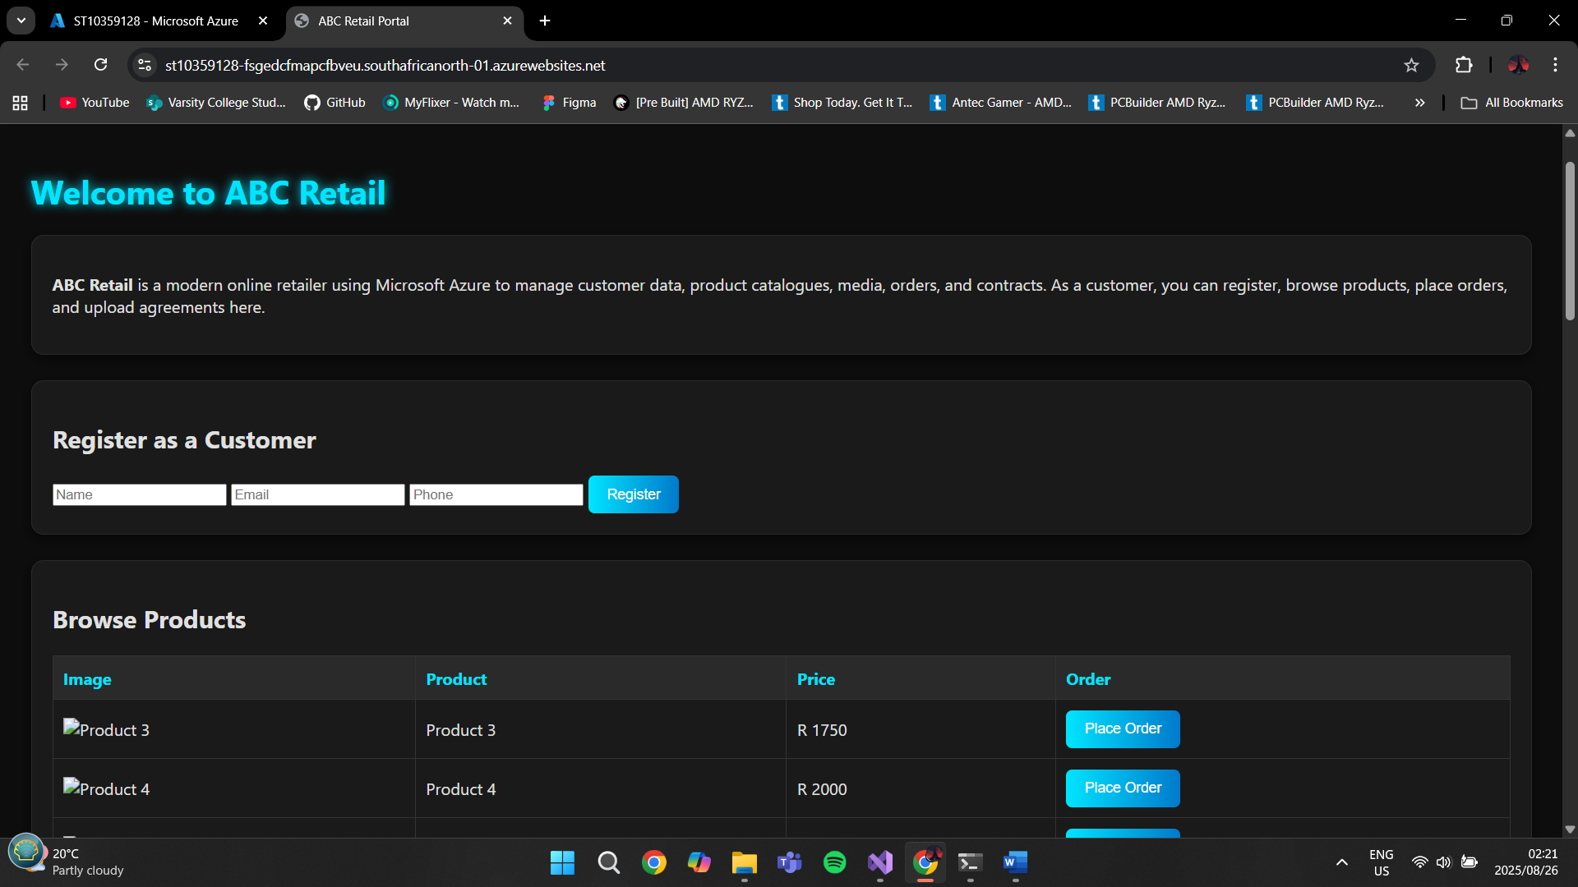

**References for part 1:**

<https://www.istockphoto.com/photos/open-laptop>

<https://unsplash.com/s/photos/smartphone>

<https://commons.wikimedia.org/wiki/File:Bijoy_Keyboard_image.jpg>

<https://www.istockphoto.com/photos/wireless-mouse>

<https://www.eizo.eu/coloredge/cs2731/features>

<https://azure.microsoft.com/en-us/get-started/azure-portal>

<https://azure.microsoft.com/en-us/get-started>

//The web portal page is how admins would see it, with the web app showing the tables, blobs, files and queues.